**Streamlining Ticket Assignment for Efficient Support Operations**

# **Team Information**

**NM_ID:**A6E219542614EFD87734619D27F02504

**Team ID**: NM2025TMID15871

Team Size: 4

**Team Leader:** H. JAYACHANDRAN

**Team Members:**  
1. BHARATH VAJ.R  
2. R.Iraiyanbu  
3. MANOHAR R V

**Problem Statement**

# In support operations, ticket assignment is often handled manually, leading to delays, misrouting of issues, and lack of accountability. This results in slower resolution times, reduced efficiency, and lower customer satisfaction. To address these challenges, a system is needed that clearly defines users, groups, and roles, while also automating ticket assignment to ensure tasks are routed to the right team with minimal effort.

# **Objective**

The objective of this initiative is to implement an automated system for ticket assignment that enhances efficiency and accuracy in support operations. By establishing users, groups, and roles, and by defining rules for ticket distribution, the project ensures that tasks are assigned to the correct individuals or teams without delays. This approach reduces the chances of mismanagement, strengthens accountability, improves resource utilization, and ultimately delivers quicker resolution and better customer satisfaction.

**Skills:**

Users,Groups, Roles,Tables, Access Control List, Flow Designer

## **TASK INITIATION :**

1. Open ServiceNow developer
2. create an instance
3. perform the tasks which is given in the project

## **Milestone 1 : Users**

## **Activity 1:** **Create Users**

1. Open ServiceNow instance
2. Click on All
3. search for users
4. Select Users under system security
5. Click on new

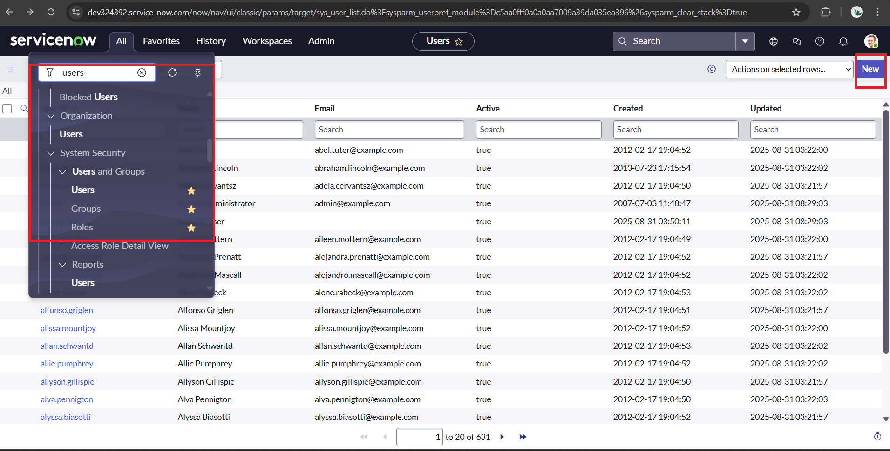

1. Create a new user by filling in details like name, email, and username
2. Click on submit

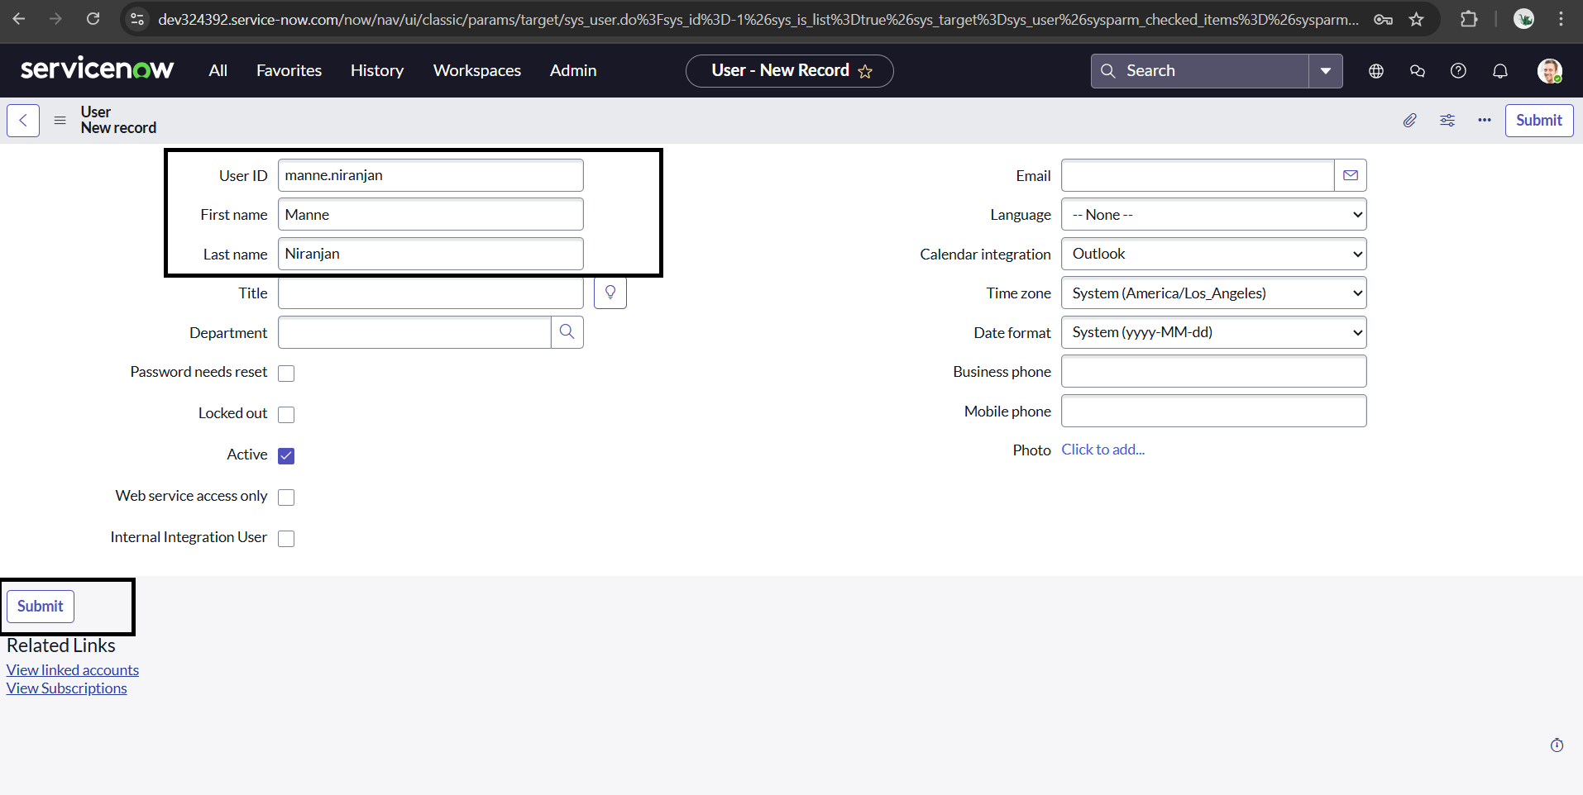

**Create one more user:**

1. Repeat the process to create another user with different details
2. Click on submit

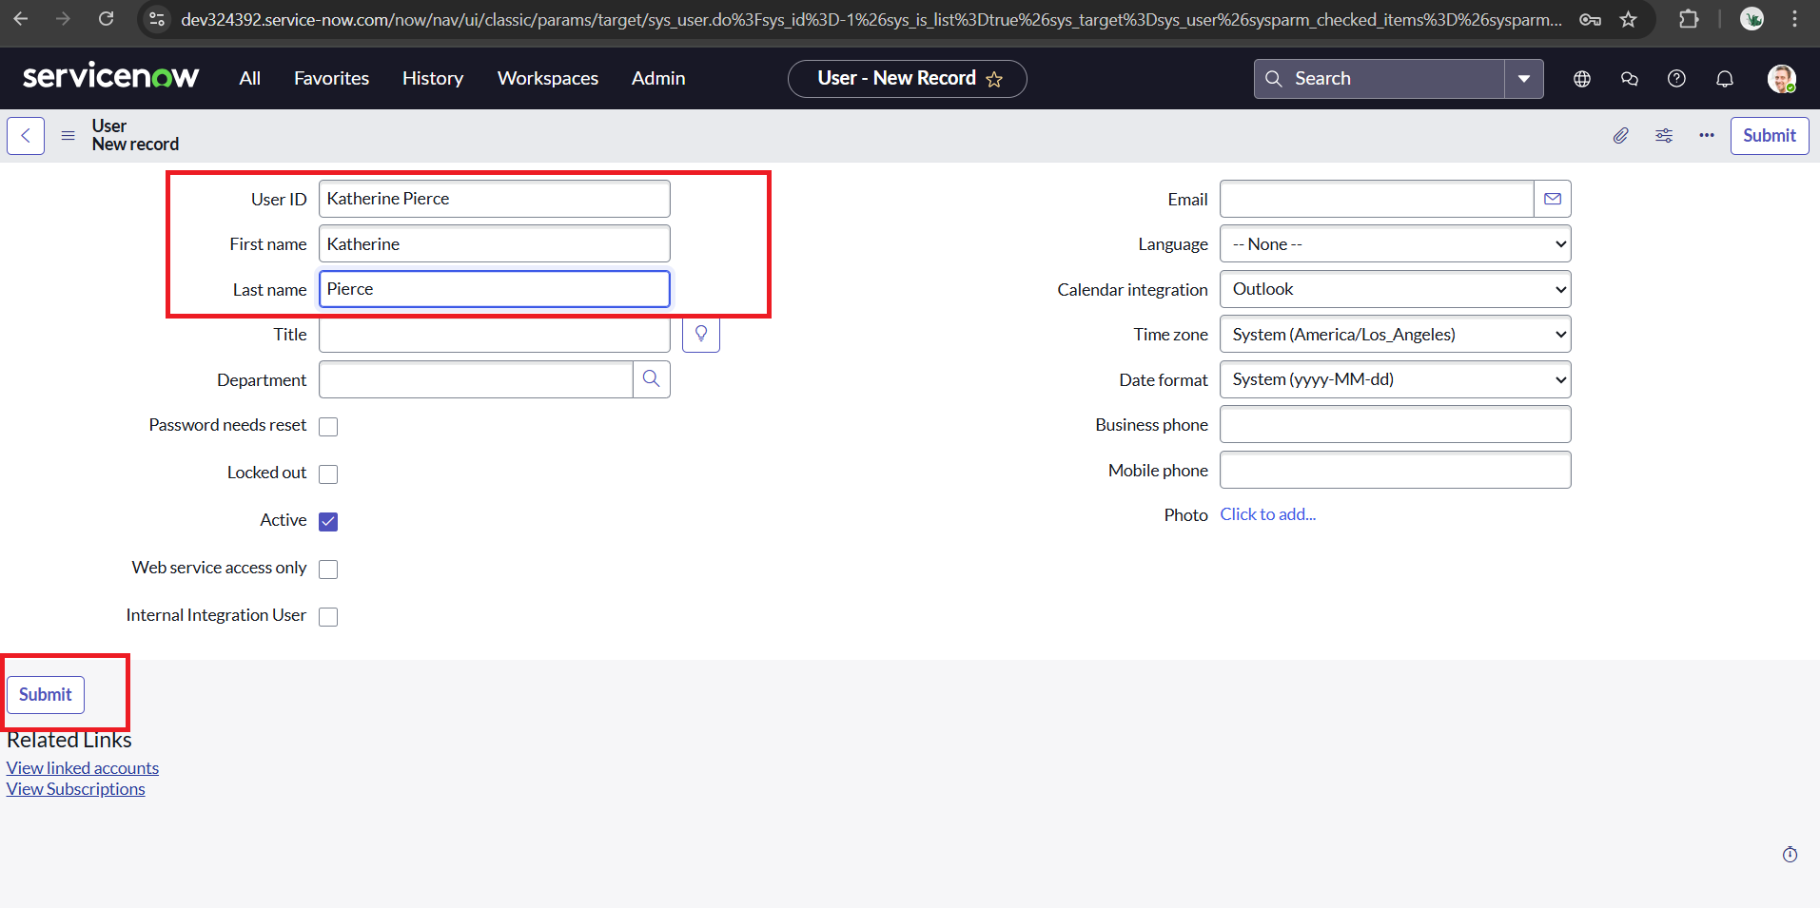

1. Confirmed that both **users** were successfully added to the **Users** list

**Milestone 2 : Groups**

## **Activity 1:** **Create Groups**

1. Open ServiceNow instance
2. Click on All
3. search for groups
4. Select groups under system security
5. Click on new

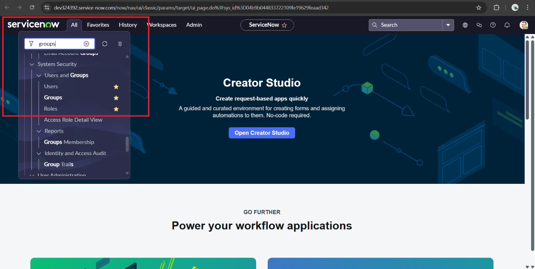

1. Create a new group named **Certificates** by entering the required details
2. Click on submit

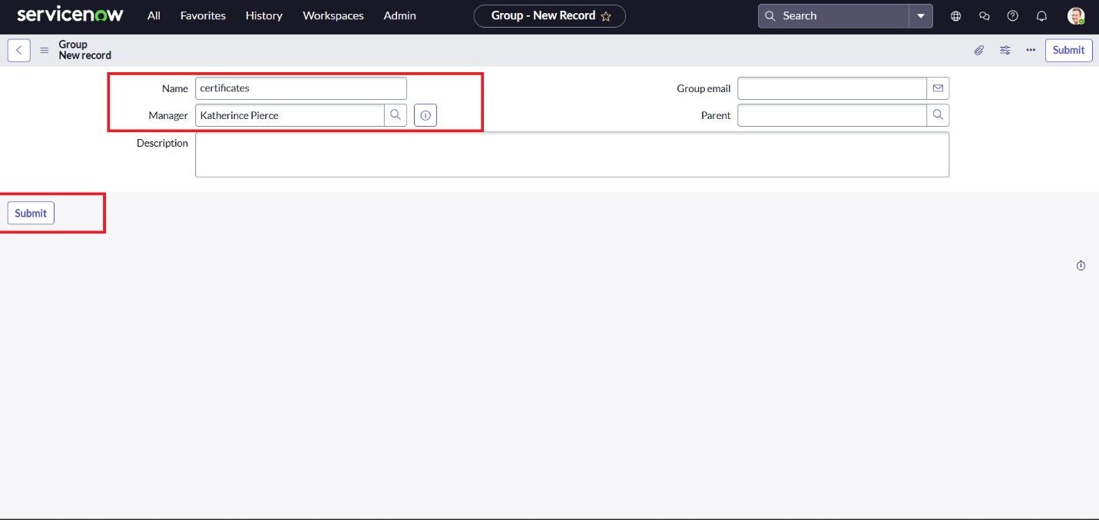

**Create one more groups:**

1. Create another group named **Platform** in the same way
2. Click on submit

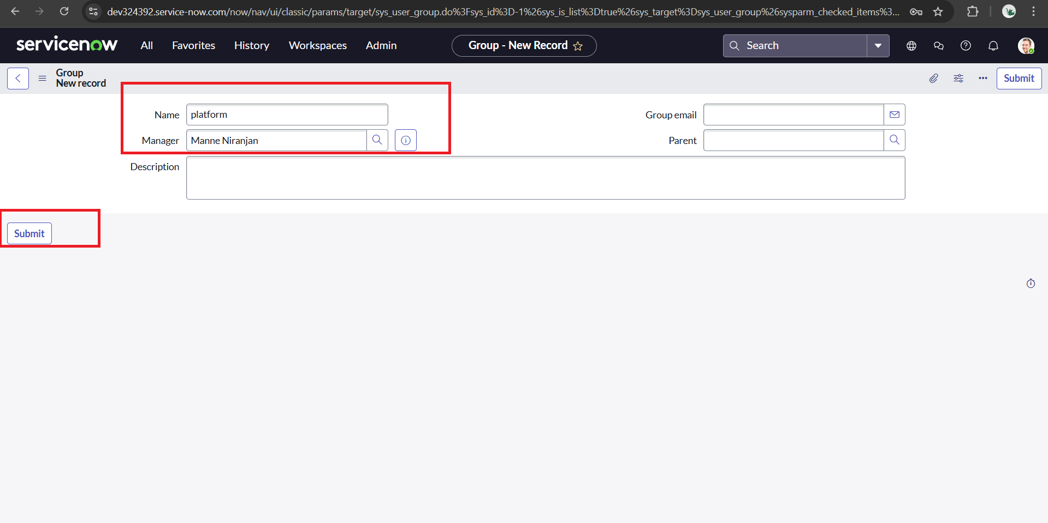

1. Confirmed that both **groups** were successfully added to the **Groups** list

**Milestone 3 : Roles**

**Activity 1:** **Create roles**

1. Open service now.
2. Click on All
3. search for roles
4. Select roles under system security
5. Click on new

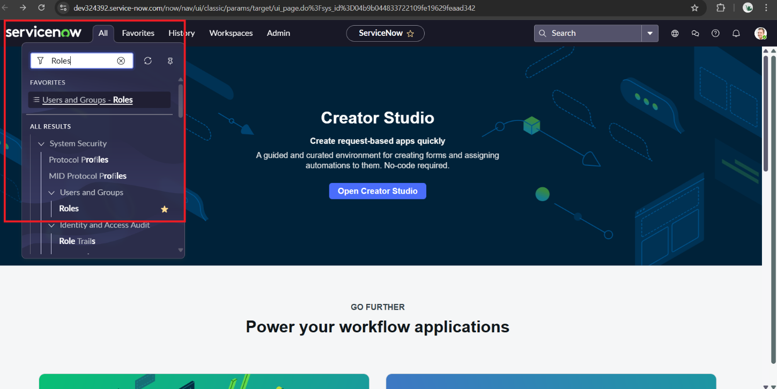

1. Create a new role named **Certification_role** by filling in the required details
2. Click on update shown in the right top corner

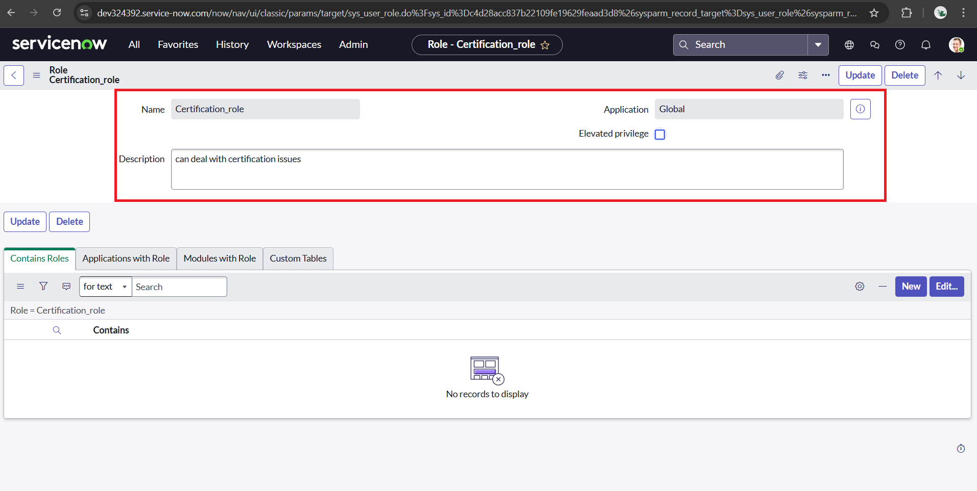

**Create one more role:**

1. Created another role named **Platform_role** using the same steps.
2. Click on update

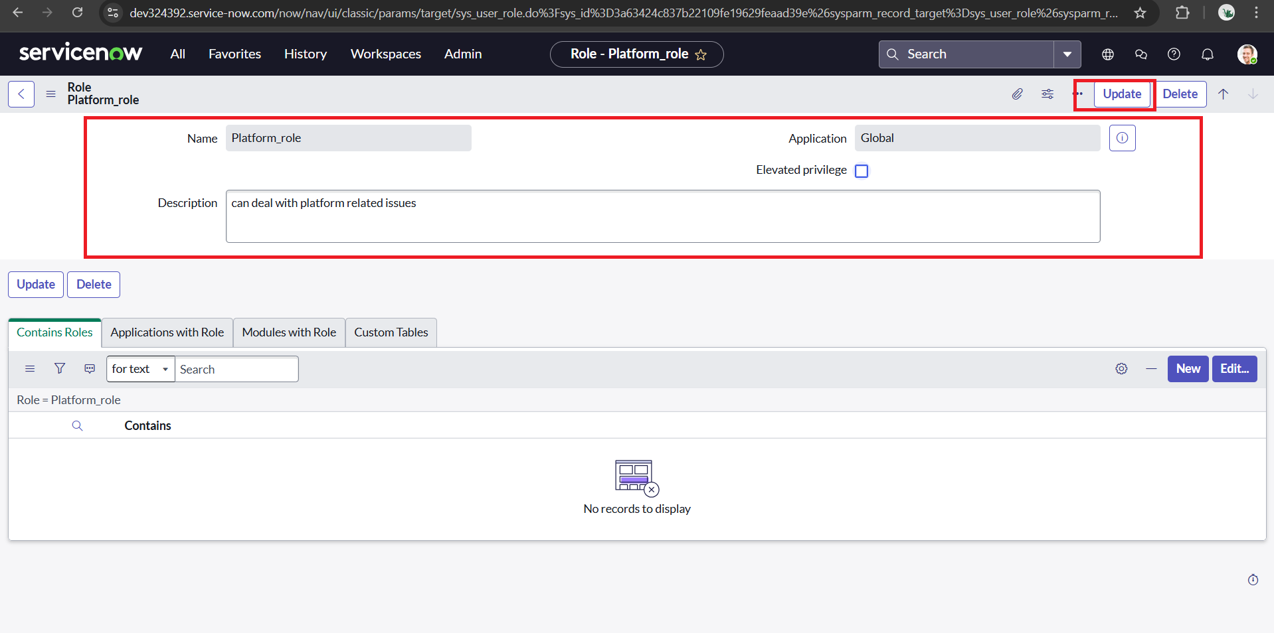

1. Confirmed that both **roles** were successfully added to the **Roles** list

# **Milestone 4 : Table**

**Activity 1:** **Create Table**

1. Open service now.
2. Click on All
3. Search for tables
4. Select tables under system definition
5. Click on new

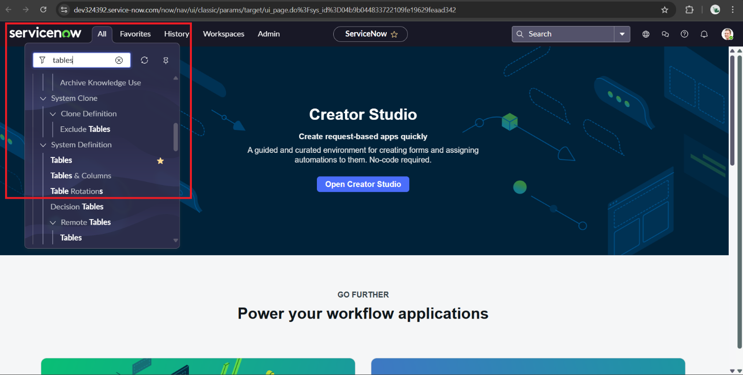

1. Create a new table named **Operations Related Table** by entering the required details
2. Enable the options to create a module and a mobile module for easier access
3. After filling the table information , Under table columns give the columns
4. insert table columns with various fields.

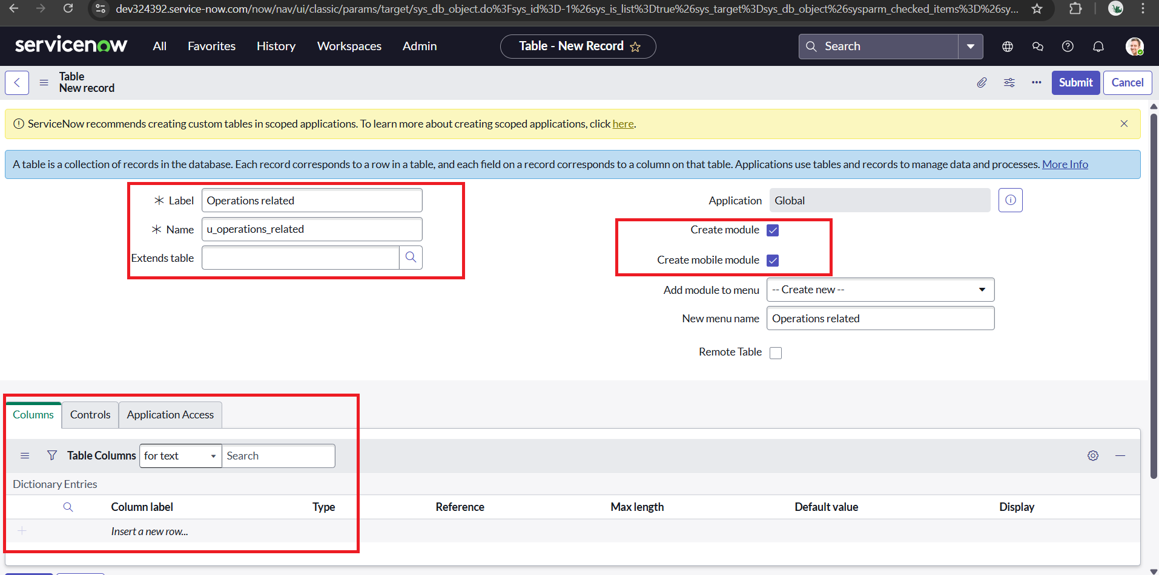

1. Insert fields such as

* **Assigned to Groups**
* **Assigned to User**
* **Comment**
* **Issue**
* **Name**
* **Priority**
* **Service Request No**
* **Ticket Raised Date**

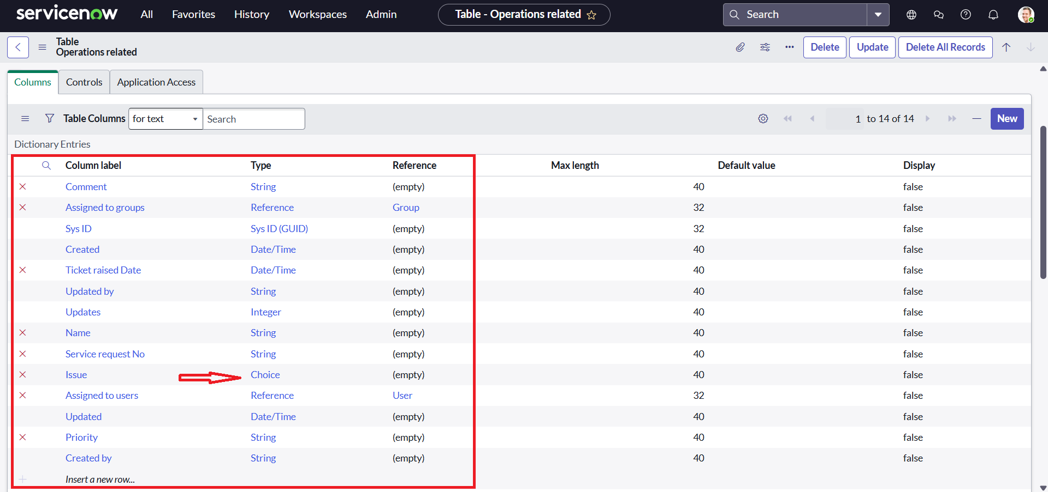

1. Click on the issue field and scroll down for the choice column.
2. Insert choice values such as **Login Issue, 404 Error, Certificates, User Expired** .

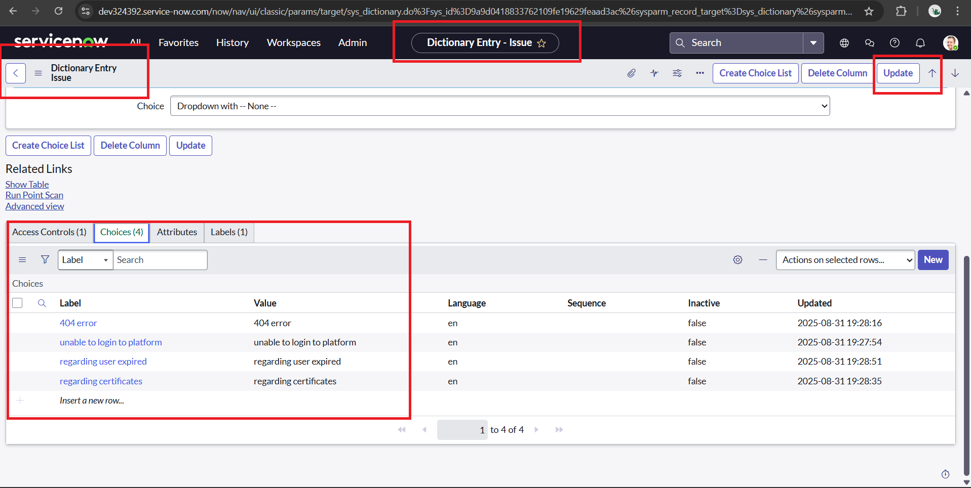

1. Click on update
2. Save the table and confirmed that it was successfully added to the **Tables** list

**Milestone 5 : Assign roles & users to groups**

**Activity 1:** **Assign roles & users to certificate group**

* 1. Open service now
  2. Click on All
  3. search for groups
  4. Select groups under system definition
  5. Search for Certicate group and select it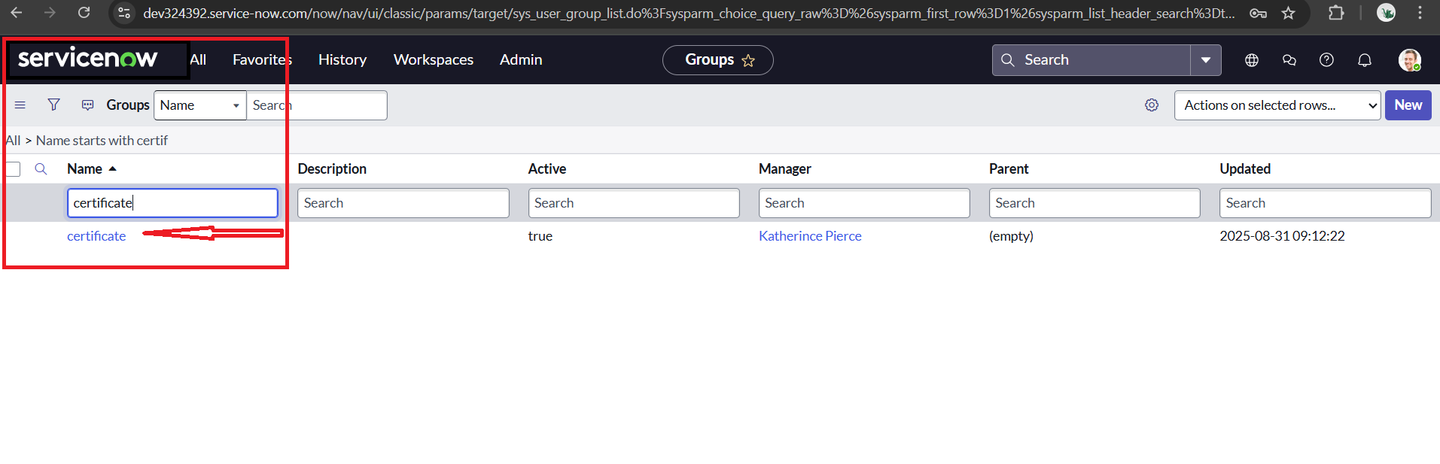
  6. Click on the roles and click edit
  7. Add the **role :** **Certification_role** and Save

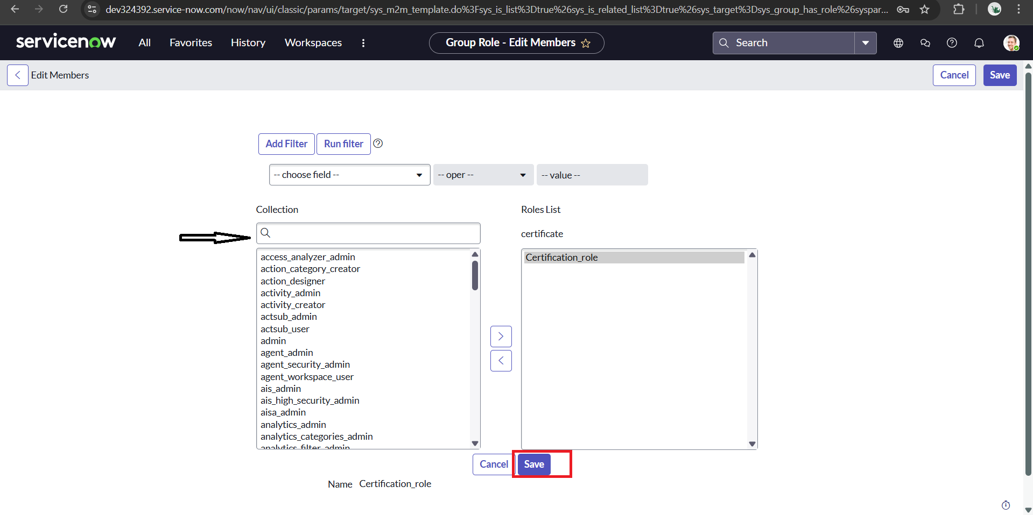

* 1. 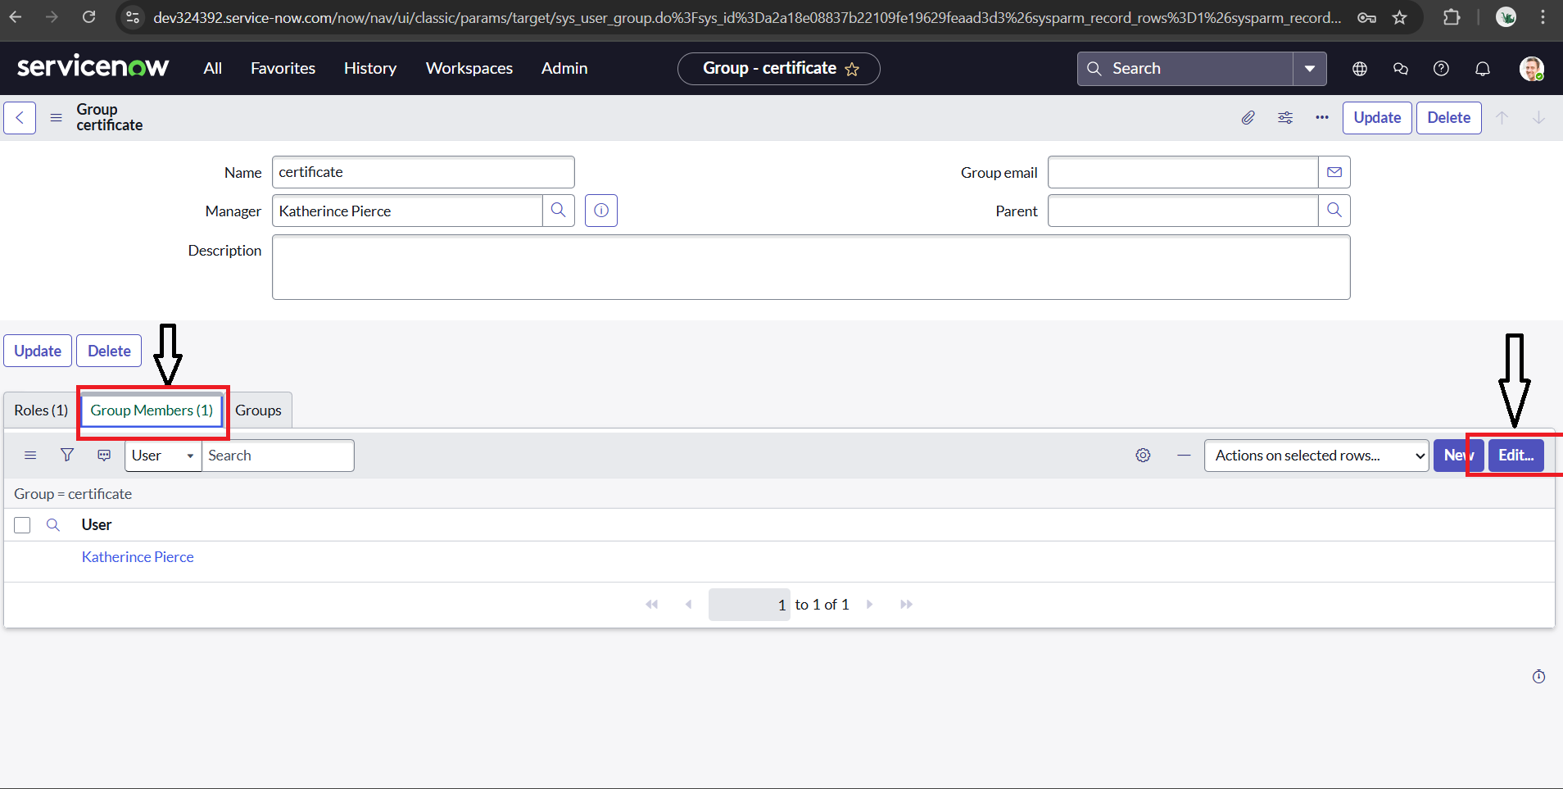After click on the Group Members and click edit
  2. 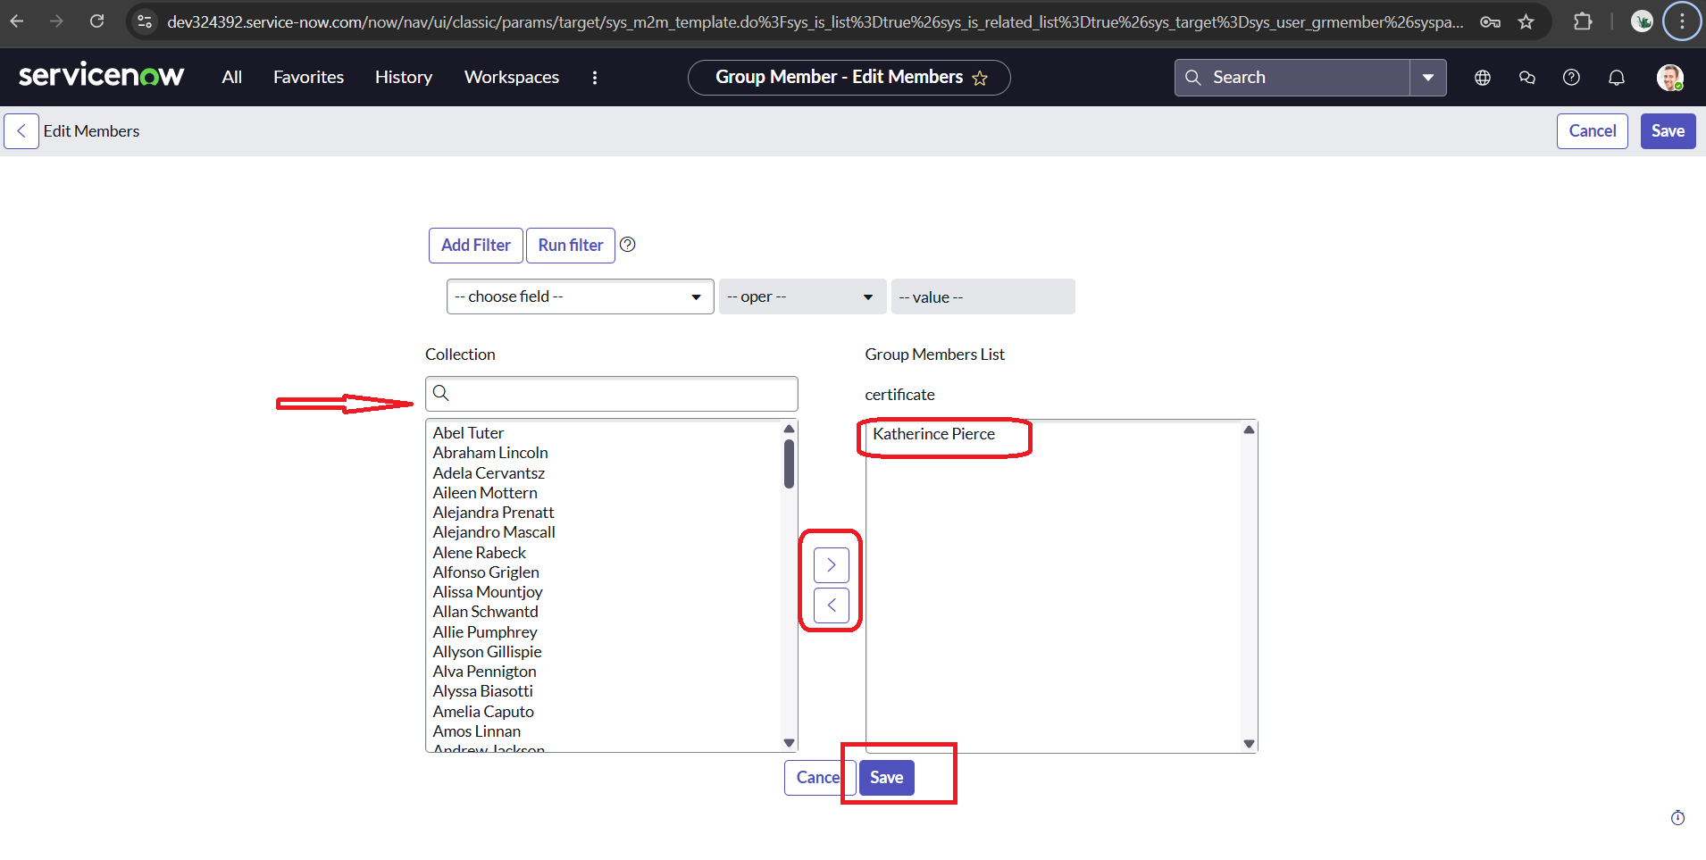Add the **Group Members:Katherine Pierce** and save
  3. confirm that the role and group members were successfully assigned to the **Certificates** group.

**Activity 2:** **Assign roles & users to platform group**

1. Open service now
2. Click on All
3. search for groups
4. Select groups under system definition
5. Search for Platform group and select it

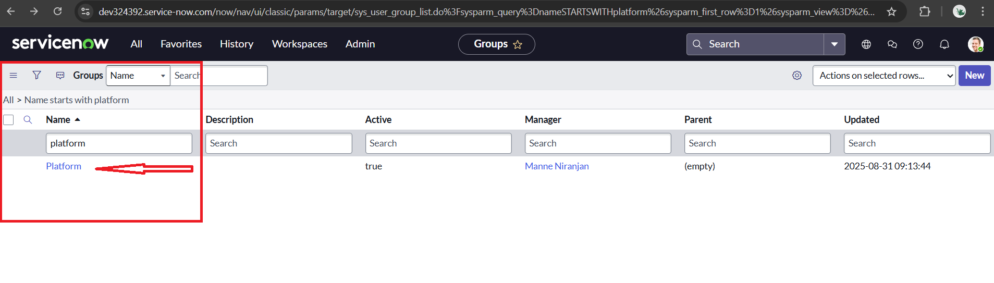

1. Click on the roles and click edit
2. Add the **role :** **Platform_role** and Save

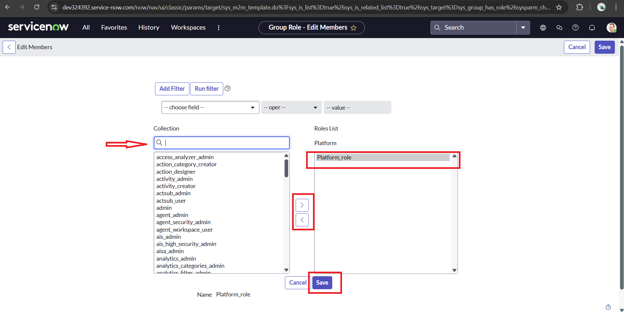

1. After click on the Group Members and click edit

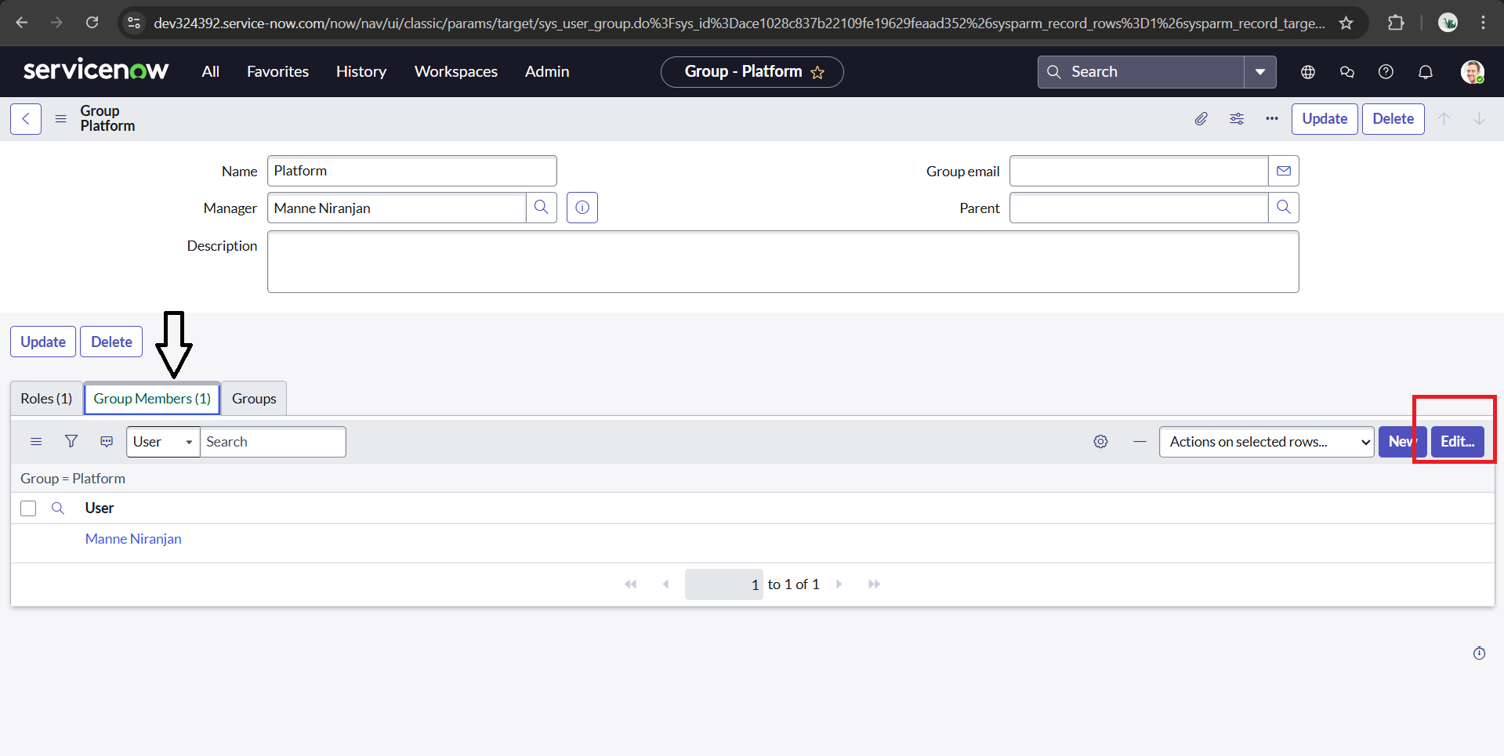

1. Add the **Group Members: Manne Niranjan** and save

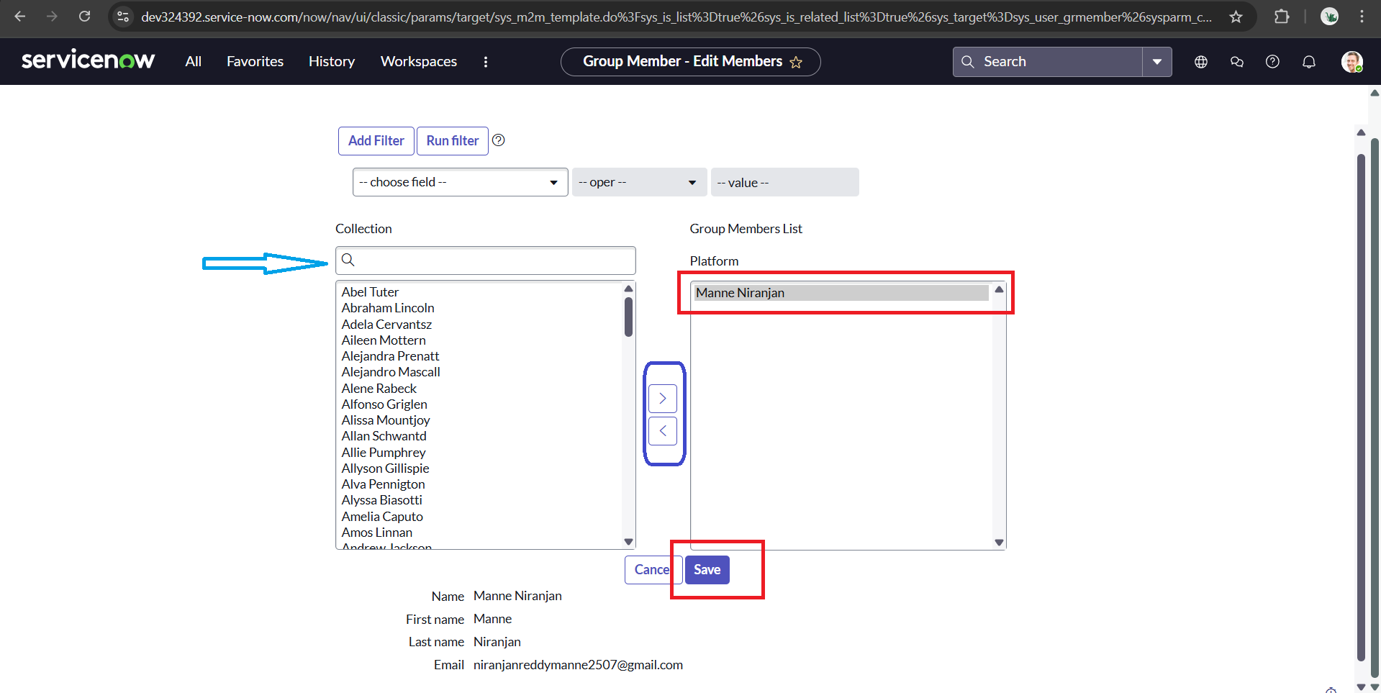

1. confirm that the role and group members were successfully assigned to the **Platform** group.

## **Milestone 6 : Assign role to table**

## **Activity 1:** **Assign role to table**

## Open service now

1. Click on All
2. search for tables
3. Select tables under system definition

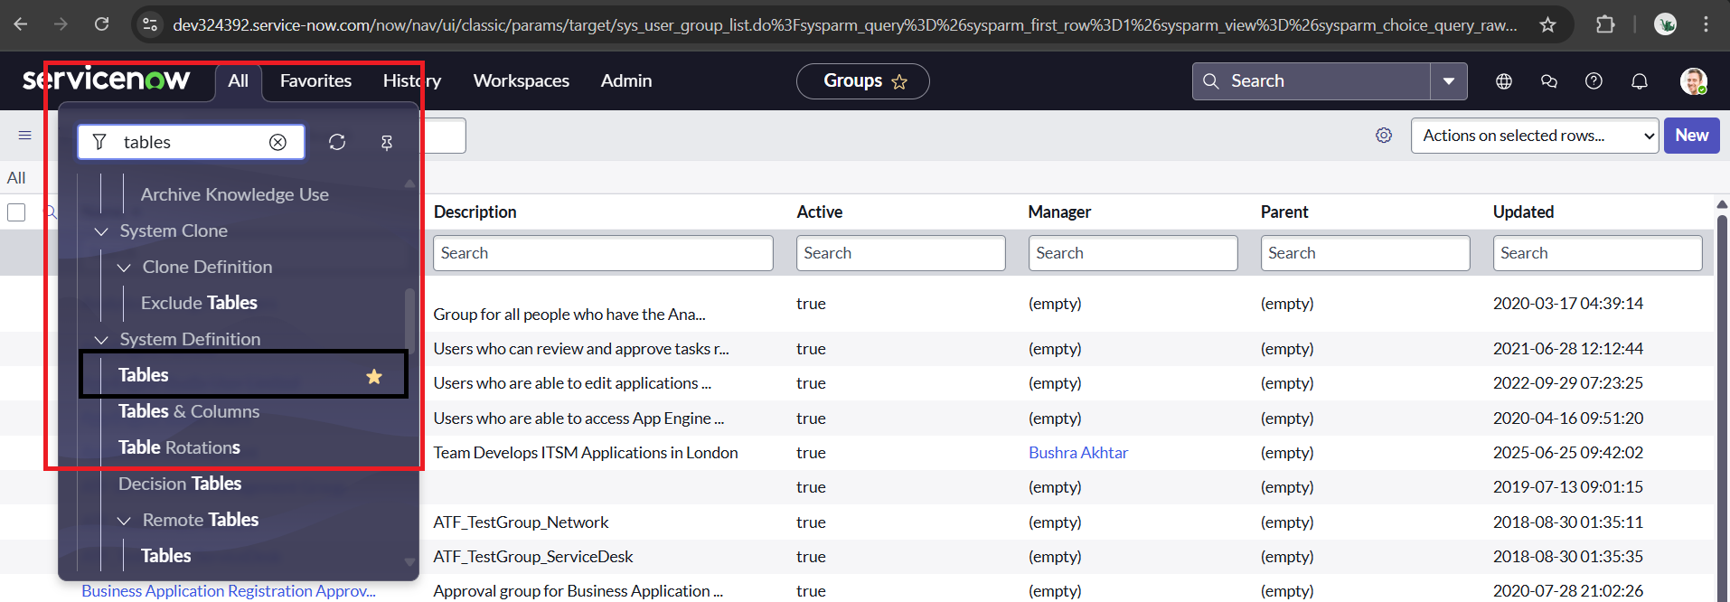

1. Search for operation related table and click on it.

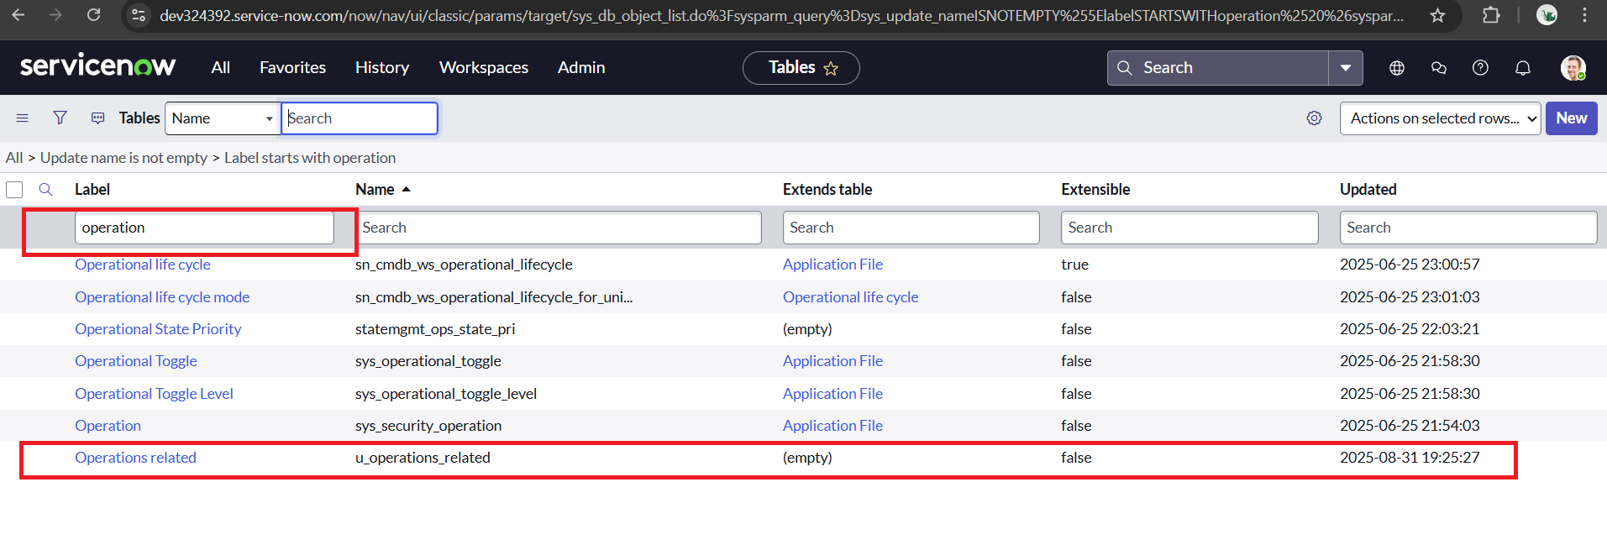

1. Scroll down, look for controls, near the column
2. Click on the control and enable the create access controls for user role
3. Click on update

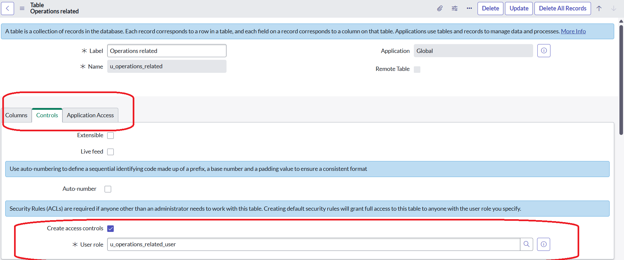

1. Click on the profile on top right side
2. Click on elevate role
3. Click on security admin and click the update

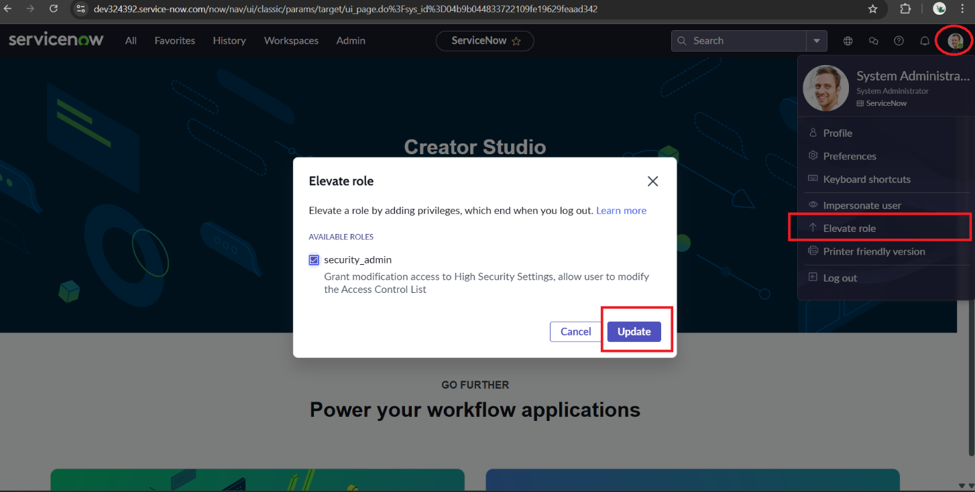

1. After that search for Access controls (ACL) in All
2. Click on the **u_operation_related** **where** operation is **read**

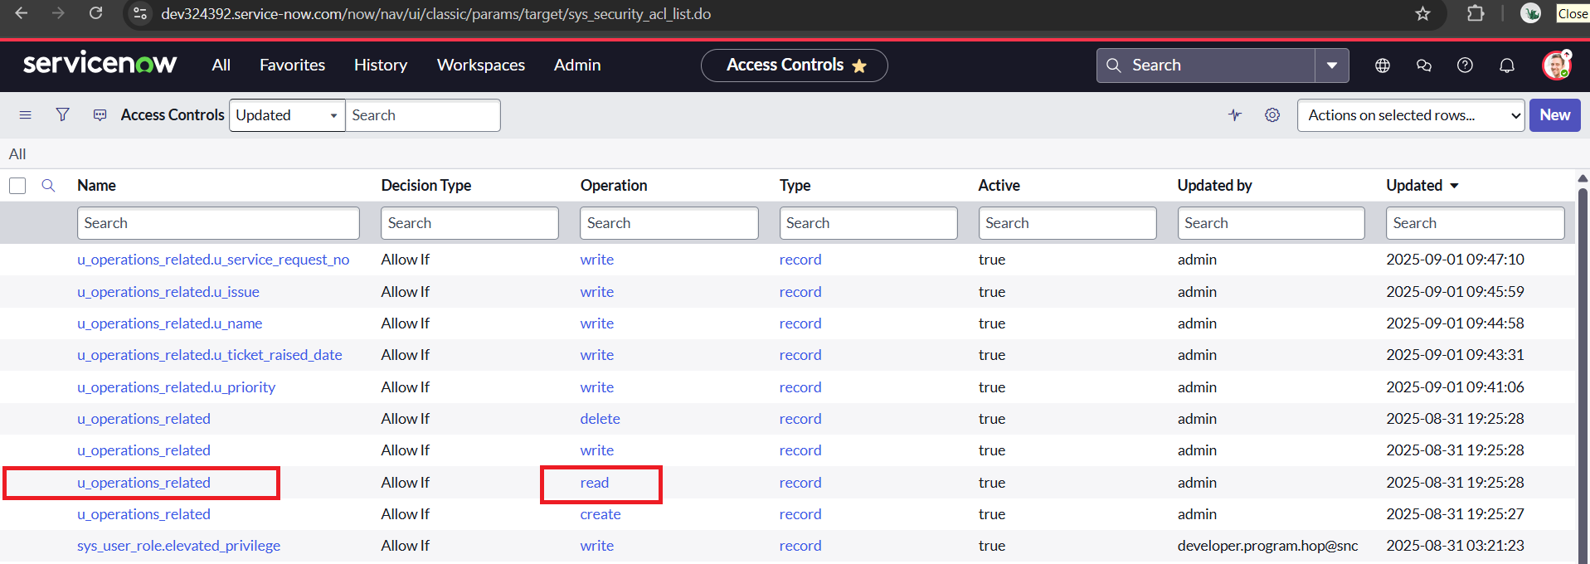

1. Scroll down for the role section
2. Add the role mentioned below:

* Platform_role
* Certification_role

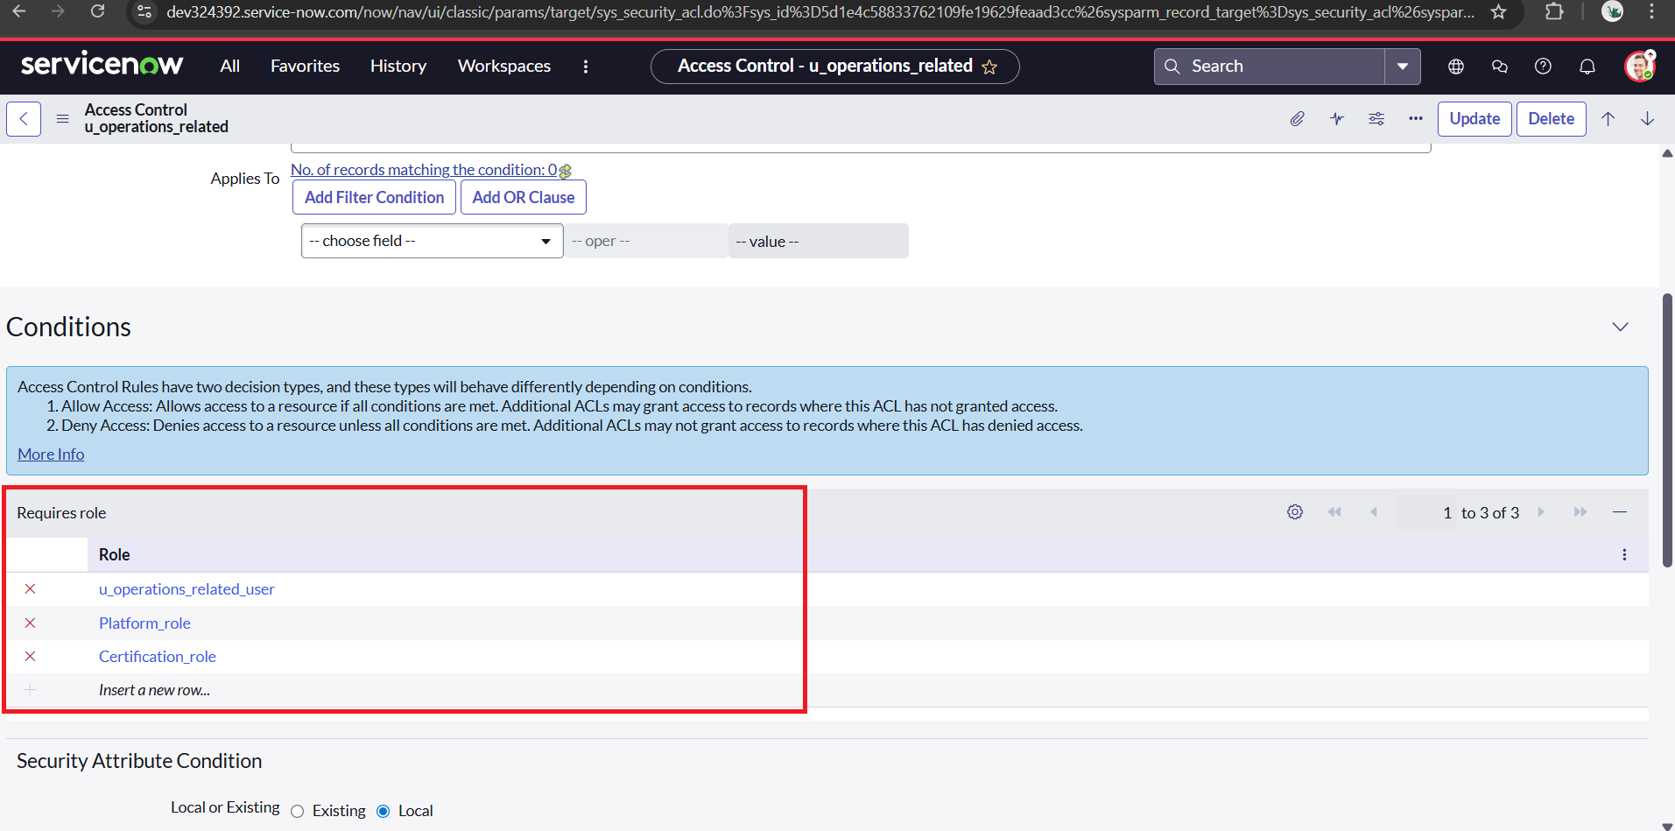

1. Click on update

**Milestone 7 :Access control list**

**Activity 1: Create ACL**

1. Open service now.
2. Click on elevate role
3. Click on security admin and click the update
4. After that search for Access controls (ACL) in All
5. Click on new

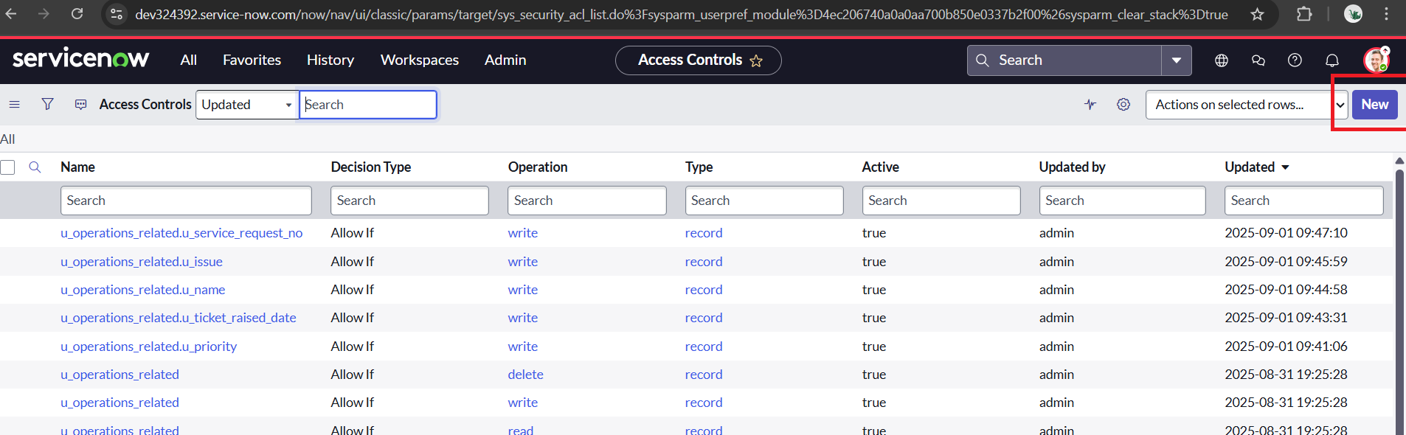

1. Fill the following details to create a new ACL
2. Mention the operation type as **write**
3. In the name enter the table name **Operation related[u_operations_related]** and

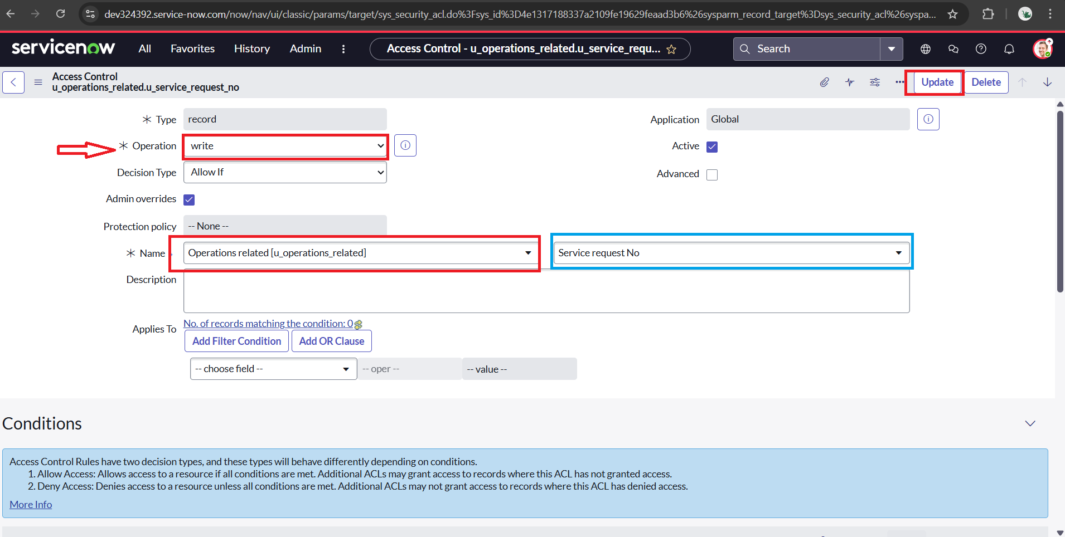Specify the field as **Service request No**

1. After that Scroll down under requires role
2. Double click on insert a new row
3. Add role as **admin** and click on update

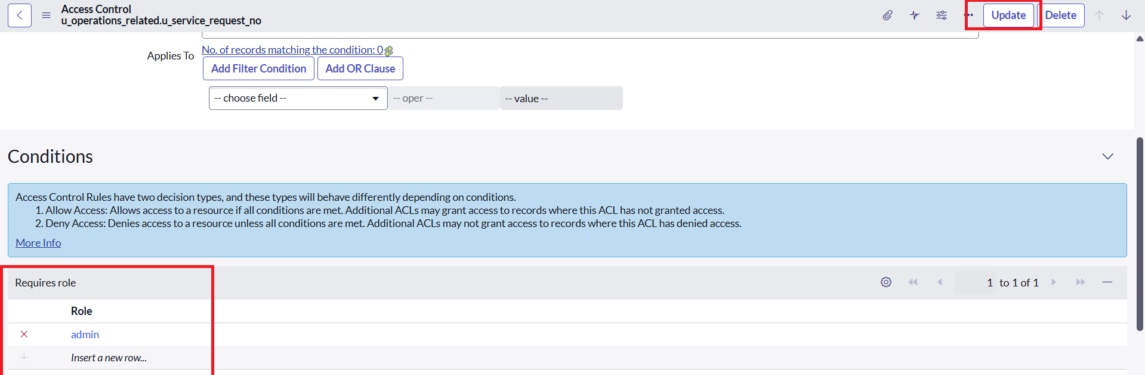

1. Thus the ACL has been created successfully
2. Similarly create 4 ACL for the following fields:
   * **u_operations_related.u_issue**
   * **u_operations_related.u_name**
   * **u_operations_related.u_ticket_raised_date**
   * **u_operations_related.u_priority**

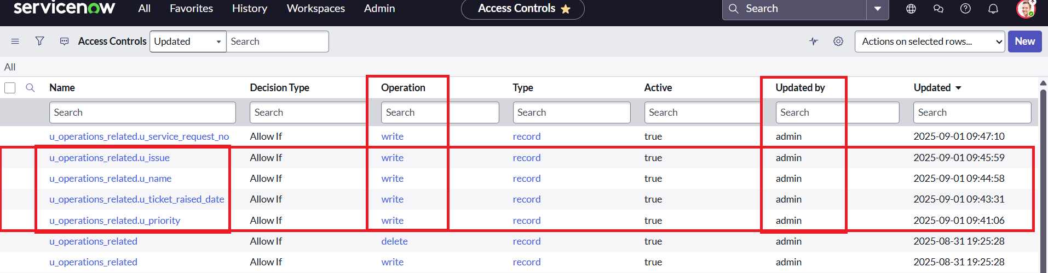

1. Confirm that the ACLs were successfully created and access was restricted according to the assigned roles.

**Milestone 8: Flow**

**Activity 1:** **Create a Flow to Assign operations ticket to group**

1. Open service now.
2. Click on All
3. search for Flow Designer
4. 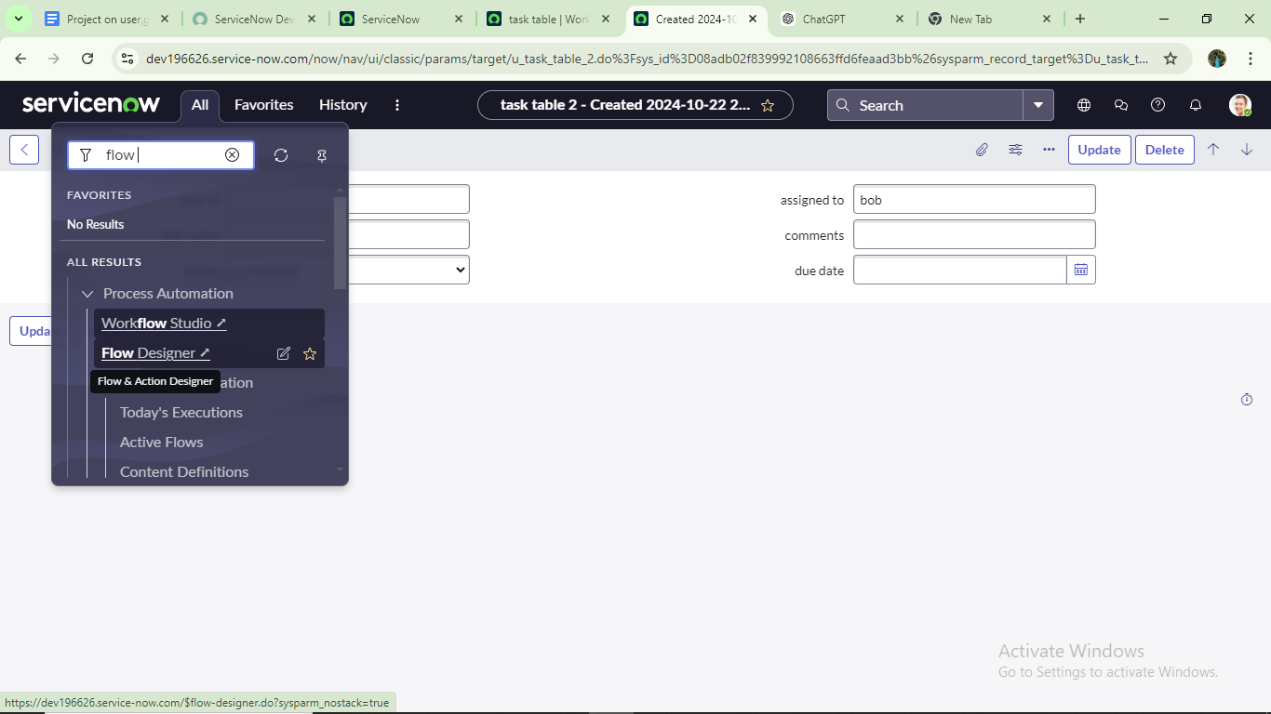Click on Flow Designer under Process Automation.
5. After opening Flow Designer Click on new and select Flow.

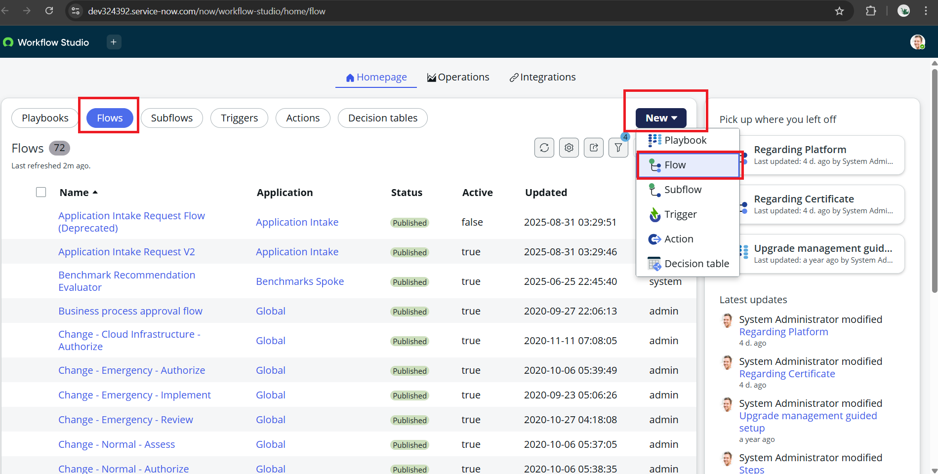

1. Under Flow properties Give Flow Name as “**Regarding Certificate**”
2. Application should be Global.
3. Click on the additional properties
4. Select Run user as “**System user**” from that choice
5. Click build flow.

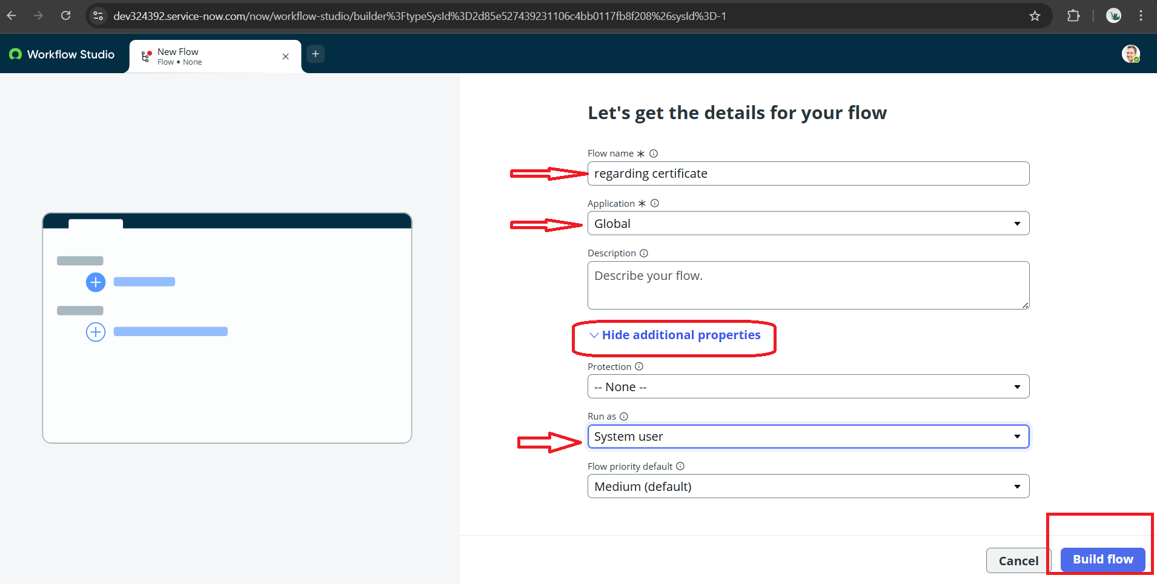

**Next step:**

1. Click on Add a trigger
2. Add a **Trigger** for **“Created or Updated”** and add table name **Operation related[u_operations_related]**
3. Give the Condition as:

* Field: issue
* Operation: is
* Value: Regrading Certificates

1. After that click on Done

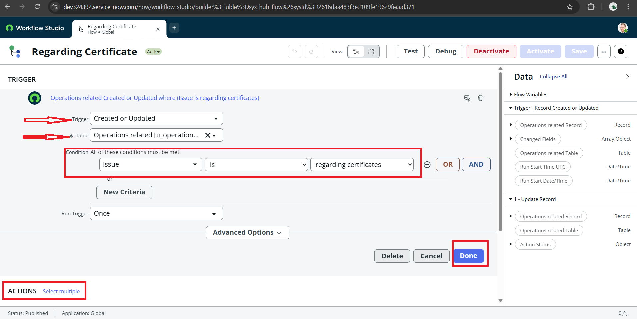

1. Now under Actions.
2. Click on Add an action.
3. Select action in that search for **“Update Record”**
4. In Record field drag the fields from the data navigation from the right side
5. Table will be auto assigned after that
6. Give the field as **“Assigned to group”** andGive value as **“Certificates”**
7. Click on Done.

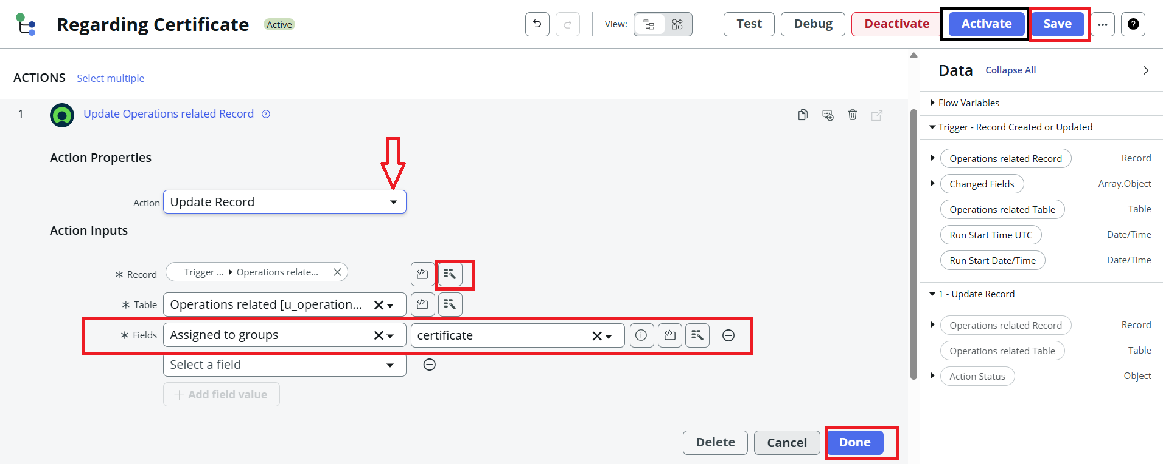

1. Click on save to save the flow and click on Activate

**Activity 2:** **Create a Flow to Assign operations ticket to Platform group**

1. Open service now.
2. Click on All
3. search for Flow Designer
4. Click on Flow Designer under Process Automation



1. After opening Flow Designer Click on new and select Flow.
2. Under Flow properties Give Flow Name as “**Regarding Platform**”
3. Application should be Global.
4. Click on the additional properties
5. Select Run user as “**System user**” from that choice
6. 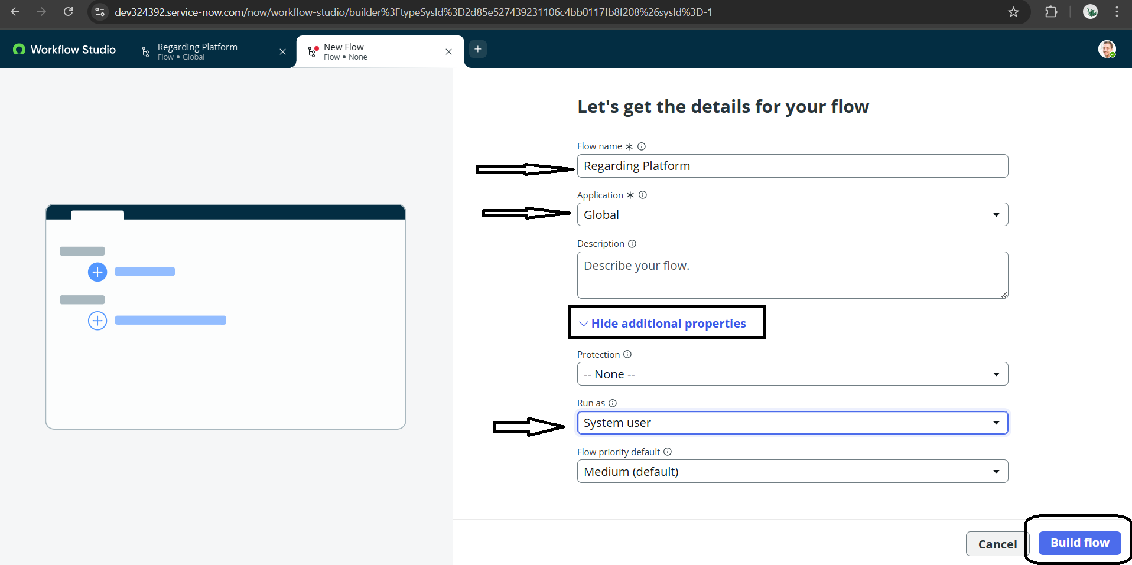Click build flow.

**Next step:**

1. Click on Add a trigger
2. Add a **Trigger** for **“Created or Updated”** and add table name **Operation related[u_operations_related]**
3. Give the Condition as:

* **Field: issue**
* **Operator: is**
* **Value: Unable to login to platform**

1. Click on New Criteria

* **Field: issue**
* **Operator: is**
* **Value: 404 Error**

1. Again Click on New Criteria

* **Field: issue**
* **Operator: is**
* **Value: Regrading User expired**

1. after that click on Done

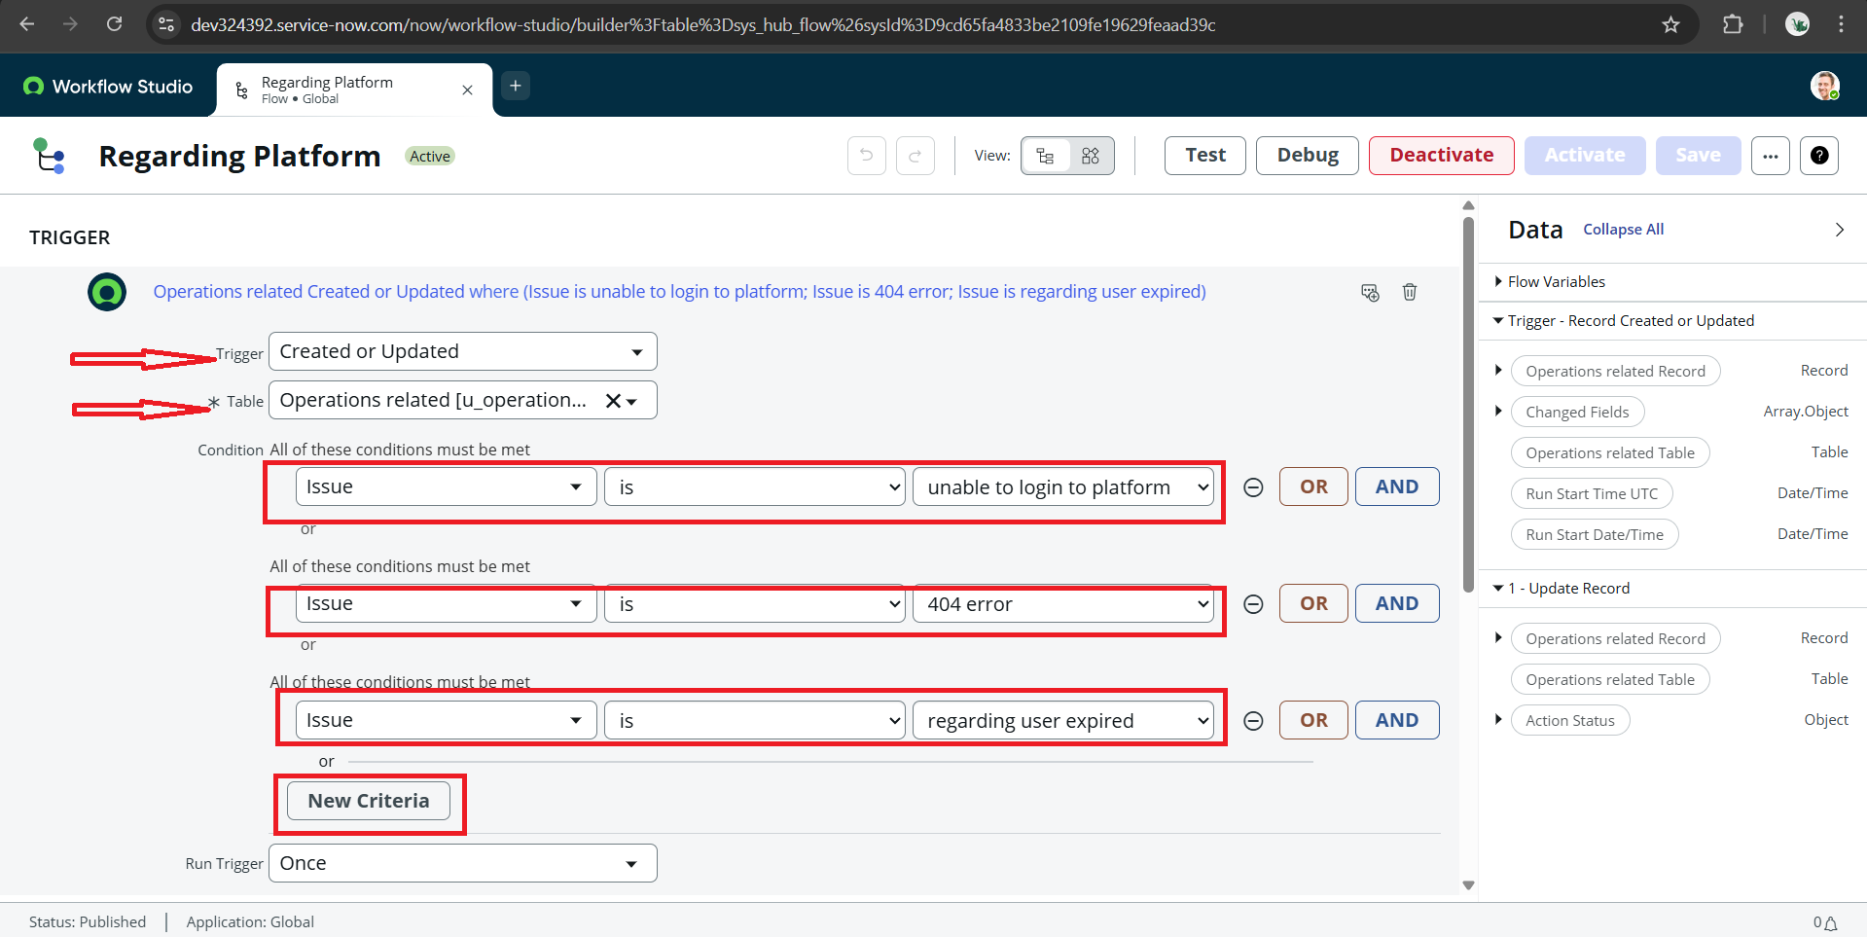

1. Now under Actions
2. Click on Add an action.
3. Select action in that search for **“Update Record”**
4. In Record field drag the fields from the data navigation from the right side
5. Table will be auto assigned after that
6. Give the field as **“Assigned to group” and** Give value as **“Platform”**
7. Click on Done.

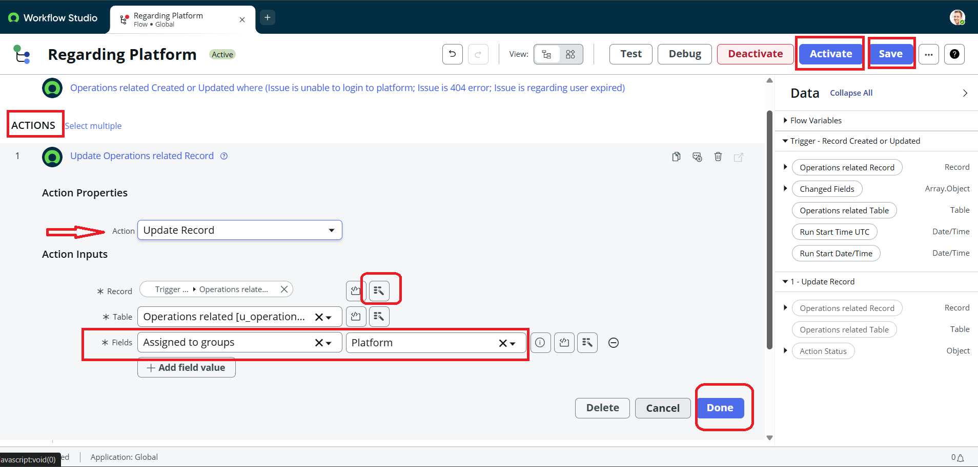

1. Click on save to save the flow and click on Activate

**Conclusion :**

This project highlights a structured approach to support management, focusing on the streamlining of ticket assignment through users, groups, and roles within a defined workflow. With clear assignments and automated flows, tickets are routed efficiently to the correct teams, ensuring timely resolution. The use of tables organizes important information, making it easier to track issues and manage progress. Overall, this system promotes accountability, improves efficiency, and contributes to the successful completion of support operations.